ASSIGNMENT 3 REPORT

COS20019 – Cloud Computing Architecture

Student Name: Cong Thanh Ngo

Student ID: 103433609

2022

CONG THANH NGO

SWINBURNE UNIVERSITY – CONG THANH NGO (103433609)

4/5/2022

# 1. Introduction

In Assignment 3, the project require to create a AWS architecture for a company that provide upload photos service for customers. The threshold company have presented some criteria for the website. This report will present my solution AWS architecture to this problem.

# 2. AWS Diagram

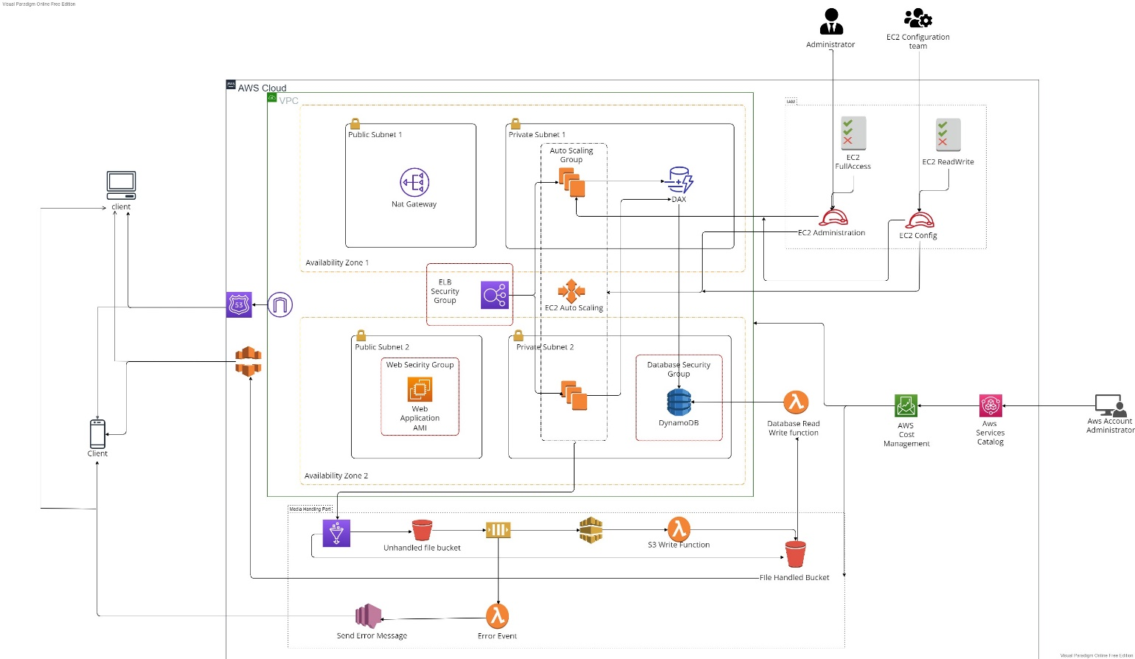

# 3. Design Rational

## 3.1. Materials.

For this project, I have conducted a small research about some AWS service, how they use, how they be implemented. List of service I have applied for the architecture:

+ **AWS Cloud Front:** Increase data transfer speed.

+ **Internet Gateway:** Allow web server to connect to Internet.

+ **NAT Gateway:** used to allow instances on a private subnet to access to services outside your VPC, but external services cannot connect to those instances.

+ **AWS ELB:** distributes incoming application traffic automatically among different targets and virtual appliances in one or more Availability Zones (AZs).

+ **AWS Auto Scaling**: analyzes applications and adjusts capacity automatically to guarantee consistent, predictable performance at the lowest feasible cost.

+ **AWS Dynamo DB**: Database to store the information of upload media.

+ **AWS S3**: Store media file.

+ **AWS Lambda**: run some micro-services function that run automatically.

+ **AWS SQS**: manage message queuing services, help building decoupled architecture.

+ **AWS SNS**: send message directly to the customers.

+ **AWS IAM**: Manage the access of AWS cloud resources and services.

+ **AWS DAX:** Boost data transfer speed to the DynamoDB.

## 3.2. UML Diagram

### a. Web Application UML

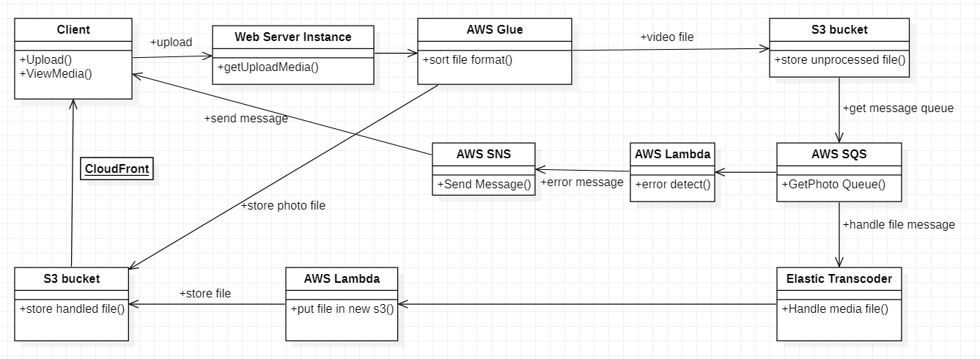

### b. Database UML

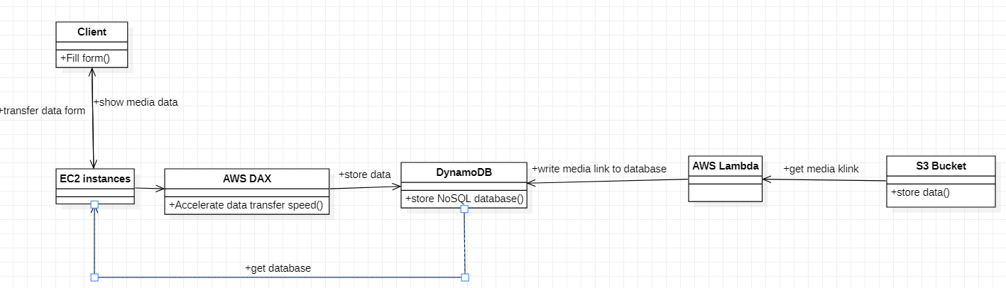

## 3.3. Justification

In design architecture, there are many option that can be replaced for the further needs or better performance of the project. There are some comparison between the requirement services:

### a. Virtual machine vs Containers vs Serverless Computing:

|  |  |  |  |
| --- | --- | --- | --- |
|  | VM(EC2) | Containers(ECS) | Serverless Computing (Lambda) |
| Performance | Instead of maintaining, optimizing, and connecting your own virtual machines (VMs), your business may spin up nearly unlimited VMs on the cloud. | ECS scales container clusters on-demand, rather than scaling compute resources like EC2. | It was discovered that the startup time for JavaScript is between 0.2 and 0.4 seconds, whereas Python is between 0.2 and 0.25 seconds. Cold start times of AWS Lambda in Go and Java spiked between 0.3 and 0.4 seconds and 0.34 to 0.4 seconds, respectively. |
| Reliability | highly dependable environment in which replacement instances can be quickly and predictably commissioned | Containerized application, application that have leverage AWS services | Operating a dependable Lambda-based application in Production necessitates operational discipline - just like any other piece of software on which your organization relies. |
| Security | +Controlling network access to your instance.   * +Managing the credentials used to connect to your instances.   +Managing the guest operating system and software deployed to the guest operating system, including updates and security patches. | Protected by the same security policies and procedures as other managed services | Cloud security is of the utmost importance. As an AWS client, you have access to a data center and network architecture designed to fulfill the needs of the most security-conscious enterprises. AWS and you share responsibility for security. |
| Cost | The instances are available with three type (micro, small, medium) with On-demand price start $0.013 per hour ($9.50 per month). | Currently the cost of Fargate spot instances for Amazon ECS in the US East region is $0.01302749 per vCPU-hour and $0.00143051 per GB-hour (see the [official pricing page](https://aws.amazon.com/fargate/pricing/) for up-to-date pricing). | The monthly request fee is $0.20 per million requests, while the free tier includes one million requests each month. Monthly ephemeral storage fees: The monthly ephemeral storage fee is $0.0000000309 for every GB-second, and Lambda includes 512 MB of storage at no extra charge. |

As the above comparison, our team choose EC2 instance to host the Web server despite the price can cost much higher. The web server demand frequently management so the ec2 instance is appropriate.

### b. SQL and NoSQL

|  |  |  |
| --- | --- | --- |
|  | SQL(AWS RDS) | NoSQL(DynamoDB) |
| Performance | Provisioned IOPS provides constant performance of up to 40,000 IOs per second for high-throughput OLTP workloads. As your storage needs expand, you can add more storage on the fly with no downtime. | It is high-performance because it can handle more than 10 trillion requests in a single day, with peaks exceeding 20 million requests per second.  Less latency and response time when reading and writing data because of the high IO performance of SSDs |
| Security | Authentication for MySQL and PostgreSQL engines is integrated with IAM. | Interacts reasonably nicely with IAM Because it is a cloud-native database, it also supports fine-grained access control through IAM policies. |
| Reliability | Provides us with an efficient database solution that can be controlled from the same dashboard as our other AWS products. | dependable system that assists small, medium, and large businesses in scaling their applications |
| Cost | $0.017 per hour for db.t2.mirco which means  $0.51 per month. | The first 25 GB consumed per month is free, and prices start at $0.25 per GB-month thereafter |

In this project, we only store a simple format database for the media record so the DynamoDB is more suitable. The price of dynamoDB is much more cheaper the the othe option.

### c. Catching option

|  |  |  |
| --- | --- | --- |
|  | ElastiCache | Route 53 |
| Performance | At cloud scale, extraordinary performance with very low latencies and negligible management expenses are possible.  144 percent more transactions per second on R5 as compared to R4’s. We reduced average (p50) and tail (p99) latencies up to 23 percent | Under normal settings, it is meant to transmit changes to your DNS records to its global network of authoritative DNS servers in 60 seconds. |
| Security | Authentication and access management ElastiCache's authentication and access control are implemented via IAM. | The AWS global network security processes are outlined in the document Amazon Web Services: Overview of Security Processes. You utilize AWS published API calls to gain network access to Route 53. |
| Reliability | Increases application and database performance, or as a main data store for non-durable use cases such as session stores, gaming leaderboards, streaming, and analytics. | Cloud Domain Name System (DNS) online service that is highly available and scalable. It is intended to provide developers and organizations with an exceptionally dependable and cost-effective method of routing end users to Internet applications by converting names such as www.example.com into numeric IP addresses such as 192.0.0.1. |
| Cost | For cache.t2.micro, it takes $0.017 per hour for On-demand use cases. It will takes $0.51 per month. | +First 25 hosted DNS zone: $0.50 per zone per month1  +Additional hosted DNS zones (over 2): $0.10 per zone per month1  +First billion DNS queries/month: $0.40 per million2  +Additional DNS queries (over 1 billion)/month: $0.20 per million2 |

Because the web server requires little queries so the Route53 is more affordable option.

### d. Push and Pull massage handling options to promote decoupling

|  |  |  |
| --- | --- | --- |
|  | Push Message(AWS SNS) | Pull Message(AWS SQS) |
| Performance | It has a throughput of up to 100 text messages per second (TPS) | SQS can process around 590 msgs/s in a one-node system (1 sender node, 1 receiver node) with one thread, with a transmit latency of less than 100 ms and a processing latency of less than 150 ms (the time it takes for a message to transit through SQS). |
| Security | Data encryption at rest is provided via server-side encryption (SSE). When Amazon SQS stores your data, it encrypts it at the message level and decrypts the messages for you when you access them. SSE makes use of keys maintained by the AWS Key Management Service. | When you access your messages, Amazon SNS encrypts them at the message level and decrypts them for you. SSE makes use of keys maintained by the AWS Key Management Service. There is no difference between accessing encrypted and unencrypted subjects when you authenticate your request and have access rights. |
| Reliability | When a message is published to a topic, Amazon SNS will attempt to notify all subscribers who have registered for that subject. Because of probable Internet difficulties or email delivery limits, the notice may fail to reach an HTTP or Email end-point. An SNS Delivery Policy may be used to manage the retry pattern (linear, geometric, or exponential back off), as well as the maximum and minimum retry durations, in the case of HTTP. | Amazon SQS locks your messages while they are being processed, allowing many producers to send and numerous consumers to receive messages at the same time. |
| Cost | These manicures may range in price from $35 to $75, depending on where you want to get your nails done and how detailed you want the design to be. | We can get free 1 million requests per month  From 1 Million to 100 Billion Requests/Month is $0.4 for Standard queue and $0.5 for FIFO queue |

We can see that AWS SQS is more supportive for the decoupled architecture, we may not have to pay for the services because the request amount is not pretty much in this project.

### e. Number of tier in the architecture

|  |  |  |
| --- | --- | --- |
|  | 2-Tier Architecture | 3-Tier Architecture |
| Performance | Direct communication occurs between the client and the server. There is no middleman between the client and the server. A two-tiered application will run quicker due to tight coupling. | Increased scalability since application servers may be installed on several computers Furthermore, the database does not require lengthier connections from each client — it merely requires connections from a smaller number of application servers. It enhances data integrity. |
| Security | Applications with Client-side Security directly connect to the database | More secure, not allow the client-side to communicate with database. |
| Reliability | Two-tier design run slower when the number of user increase. | When implemented on several servers, a three-tier design makes it simpler to boost system stability by incorporating various levels of redundancy. |
| Cost | 2-tier applications are generally easier to build and because of their lower complexity are less expensive all around. | 3-tier application is more complicate to build, it needs more resource so the cost should be higher. |

Three-tier architecture is the most common design for application nowadays, this design make the app run faster, more secure and highly availability. The downside of this design is that it is more difficult to design and the cost is more expensive.

# 4. Alternative Design

For the first design, when it comes to the disadvantage, I can see that it’s not really support for the decoupling design that means when the application corrupts, it will takes lots of time in recovery action. Also, not all the request form the clients are implemented successfully. Moreover, I realize that the database need more management so establish a database team is needed.

